ITPFL4
ADVANCE WEB APPLICATION DEVELOPMENT
ENDTERM PROJECT

Sandigan, Elaine Mae
Roilo, Jeremiah
Jereza, Mikylla Nicole
Juban, Christine
Jastillina, Trixie Nicole
Mondejar, Lyca
Arguelles, Mary Rose

BSIT 3-A

JANUARY 9, 2026

Project Overview

Brief Summary

The name Tropicart is a portmanteau derived from "Tropic" and "Cart," perfectly articulating the platform's vision to function as a global marketplace for exotic goods. The developers established this e-commerce site with the core mission of sharing authentic tropical flavors with the world, primarily by using a curated selection of beverages and drinks as their initial main product line, thereby ensuring that people anywhere can easily order and savor products sourced directly from tropical islands.

Target Users

The target users for Tropicart are primarily the Flavor and Experience Seekers—adventurous consumers, often Millennials and Gen Z, who are actively looking for exotic, authentic, and unique flavors unavailable in their local markets, driven by a desire for culinary novelty and cultural exploration. A secondary but crucial segment includes the Health & Wellness Consumers who prioritize natural ingredients, functional benefits, and transparency in their beverages, seeking out drinks like specialty coconut water or unique fruit juices for their inherent health properties. Finally, the platform also caters to Hosts and Entertainers looking for premium, distinctive mixers and non-alcoholic options for social gatherings, as well as the "Taste of Home" Buyers—including expatriates and frequent travelers—seeking specific, hard-to-find tropical brands to satisfy nostalgia and comfort. These users are typically active online shoppers willing to pay a premium for high-quality, specialty, and imported goods that deliver a genuine tropical experience.

Core Features
This explains the core Features of Tropicart on its User and Admin side.

User Side
The following are the core features of the Tropicart in its user side

Signup (User Data Capture & Validation)
1.Account Registration- Collects essential user credentials: Username, Email Address (for communication and recovery), and a secure Password. This process includes client-side checks (like password strength) and server-side checks (like email uniqueness).
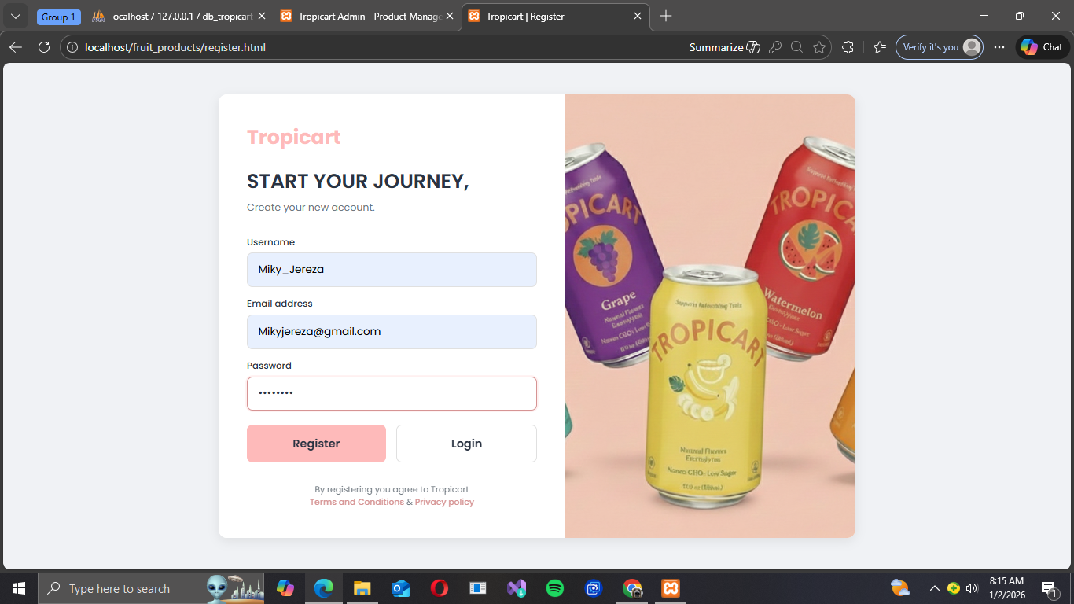

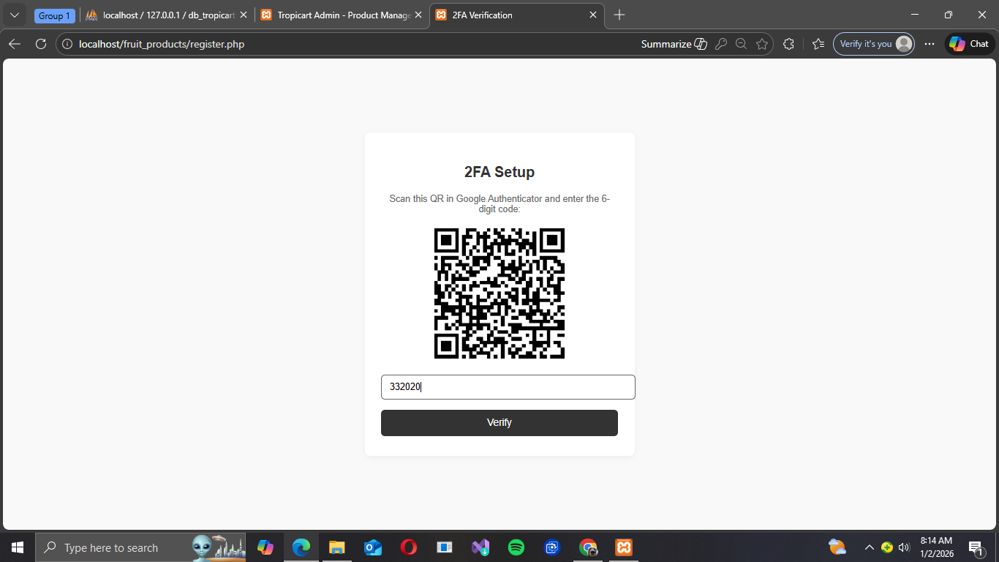
2 Factor Authenticator- Upon successful registration, the user is prompted to set up an additional layer of security, typically via a QR code scan using an Authenticator app. This generates a time-based code, making unauthorized access significantly harder.

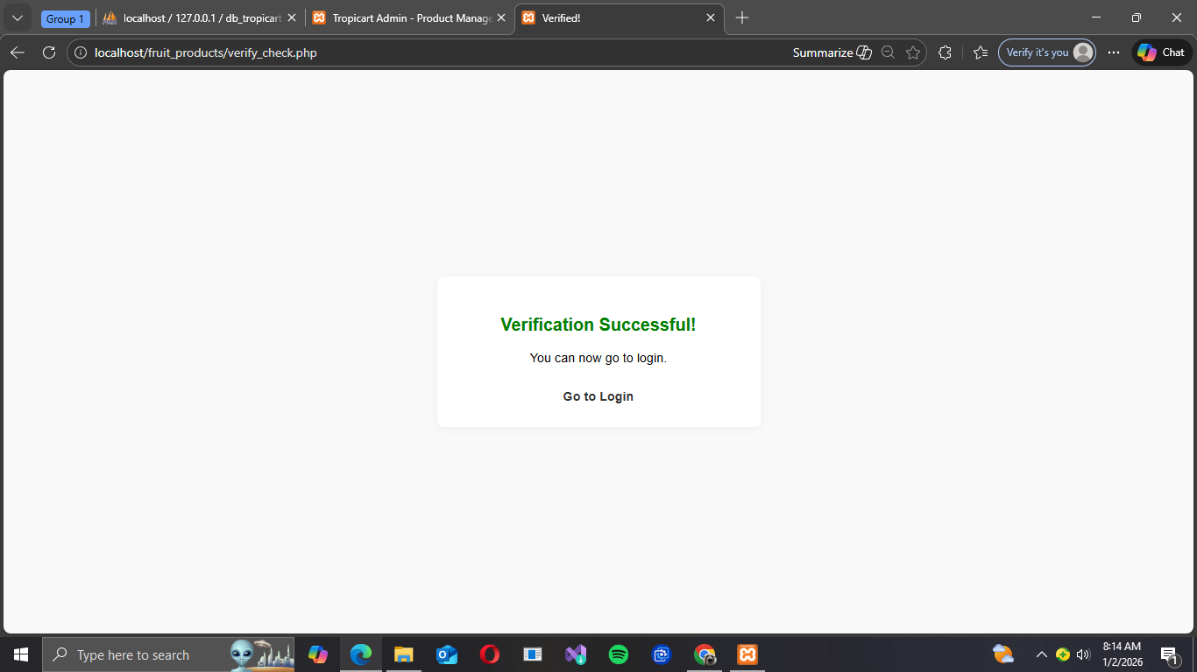

If successful

Login (Credential Authentication & Session Management)
Account Verification- When a user logs in, the system verifies their input against the securely hashed data in the database. Successful verification triggers the creation of a secure session token, which allows the user to access protected pages (like My Orders) without re-logging in.
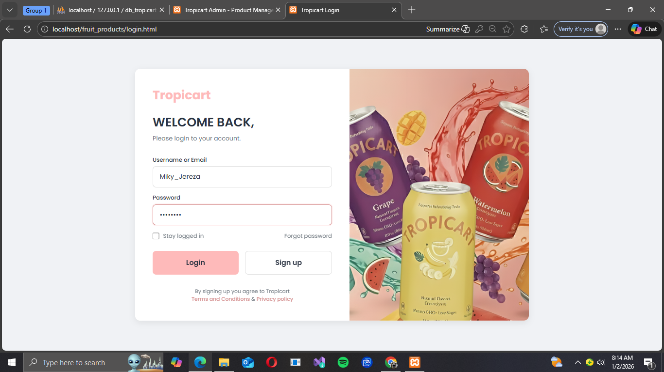

Landing Page (Global Navigation)
Navigation-Provides a clear, consistent structure across all pages, allowing easy access to key site sections: Products (Shop), My Orders, About Us, and Contact. This is usually implemented in a header or sidebar for maximum accessibility.

Product Page
Product cards- Products are displayed in standardized, concise card format within a grid. Each card highlights the product image, name, price, and a direct Call-to-Action (CTA) button.
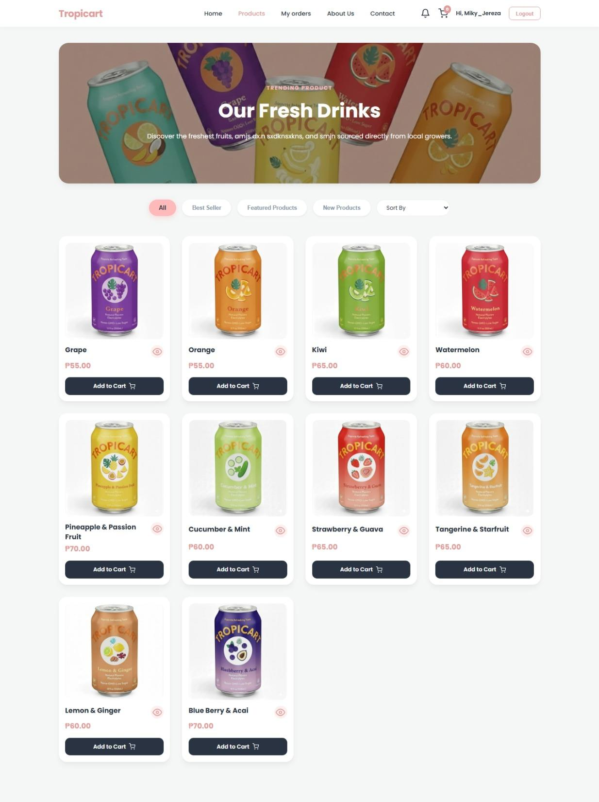

Sorting- Allows users to reorganize the product list based on popular criteria: All Products, Best Seller, Featured Products, and New Products. This improves product discoverability.

Add Cart - The primary conversion action. This feature allows the user to instantly add a product (and quantity) to their persistent Shopping Cart session for future purchase review.
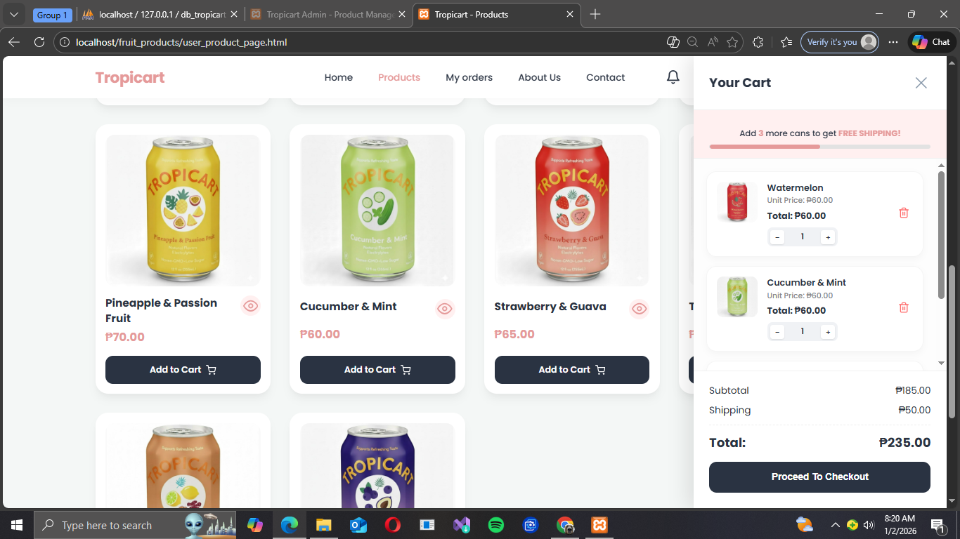

Checkout Page
Shipping Information- Collects all necessary details for fulfillment. Users choose between Delivery to Home or In-Store Pickup. The form captures Full Name, Email, Phone Number, City, Full Address, and Zip Code, ensuring accurate logistics.
Payment Method- Users are presented with secure, flexible payment options: Credit/Debit Card (via a payment processor), Gcash (a common mobile payment option), or Cash on Delivery (COD). A transparent, finalized Total Amount is displayed before payment submission.
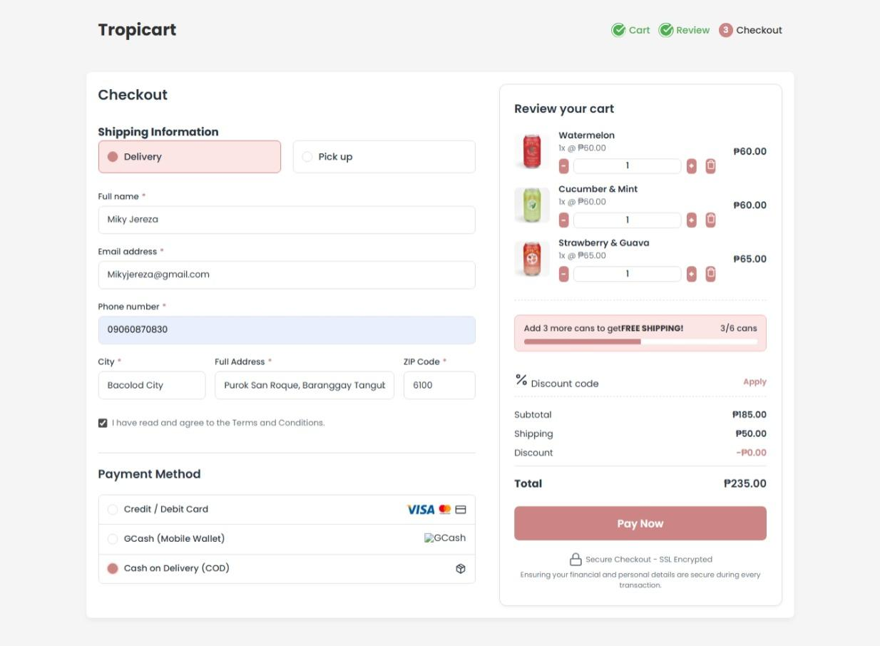

My Orders Page
Order Tracking & Management-The user can review past and current orders via a searchable list showing OrderID, Date, Total Amount, and Current Status (Pending, On Delivery, Complete).
Pending Cancellation- Provides a limited window for the user to Cancel the order, strictly only when the status is Pending (before Admin approval).

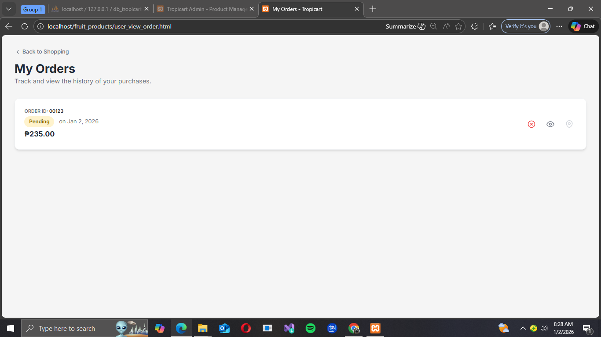

Order Details Viewer- An Eye icon provides a detailed view of the specific shipping and payment credentials used during the checkout process for that order.
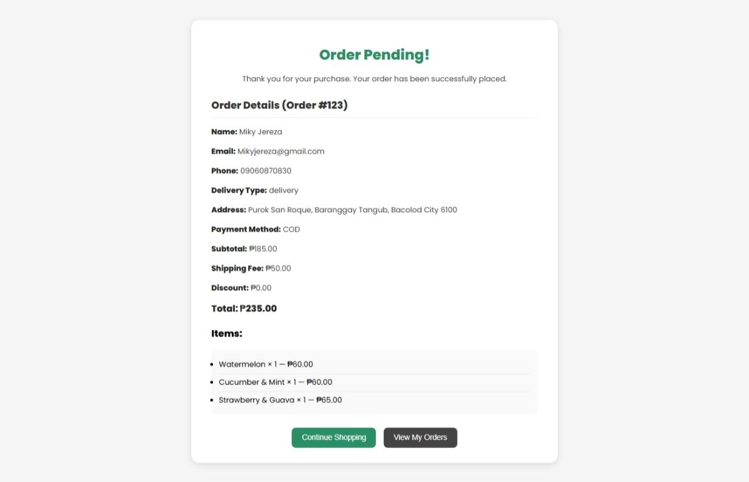

Delivery Path- Once the Admin approves the order and it moves to On Delivery status, the user gains access to a dynamic map view showing the rider's current path/location.

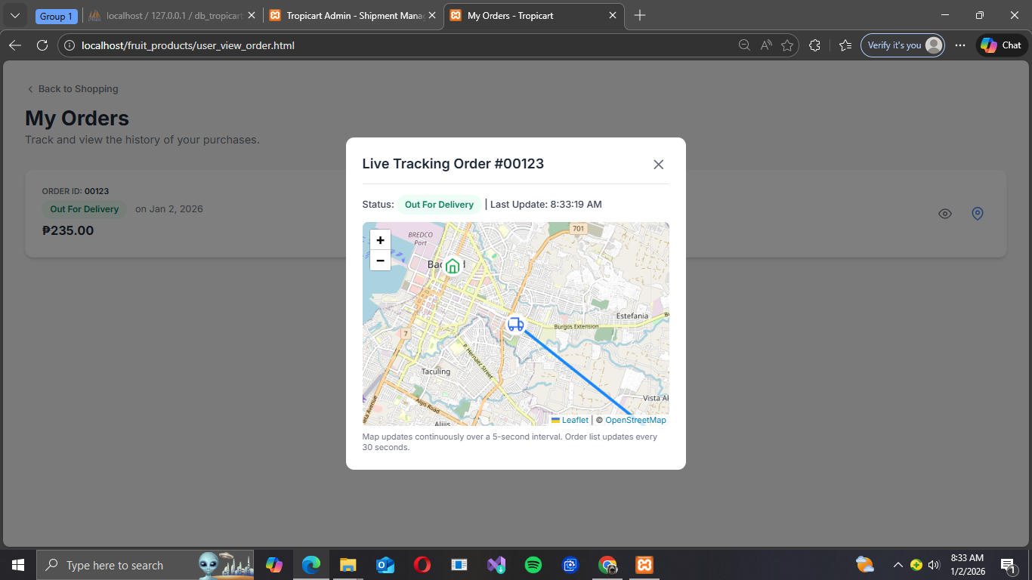

Admin Side
The following are the core features of Admin side

Admin Signup
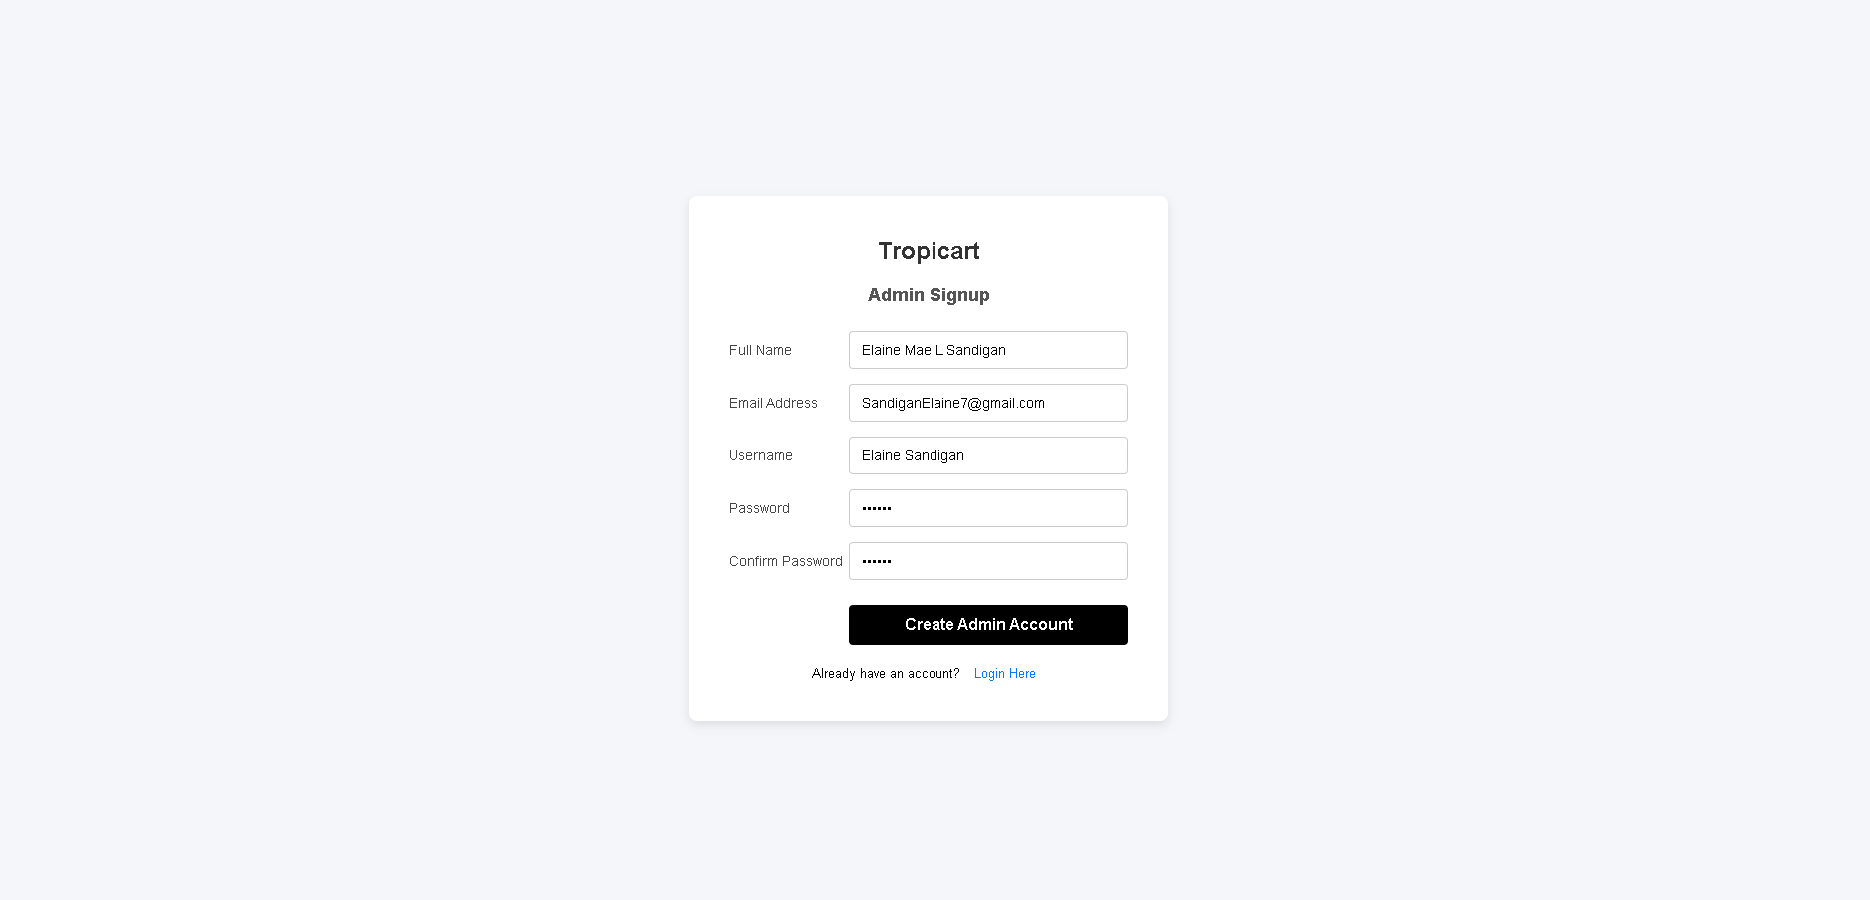
Admin Register- It includes The Full name, Email Address, Password and Confirm Password. also you cannot easily create a admin if you are a user since it is only exclusive to the staffs managers of the establishment

Admin Login
Credential Verification-Accepts the Username/Email and Password, verifies the hashed password against the database, and only grants access if credentials are a perfect match.
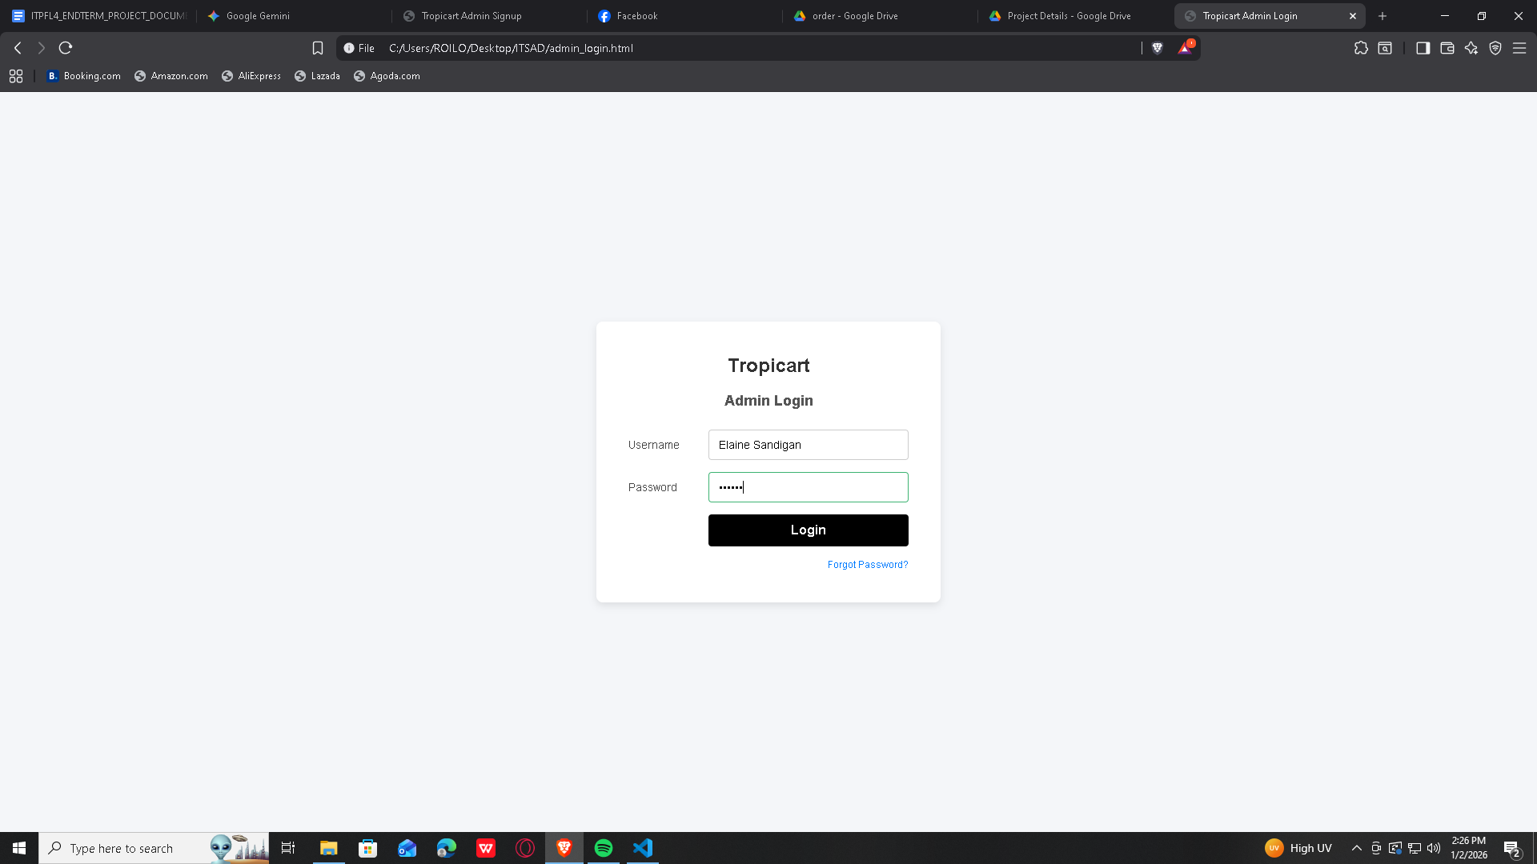

Dashboard
Navigation- In this section of the page, all of the functions can be location including the summarization of the reports, Management and under it is the 3 key factors of being an admin that is the handling the Product list, Order list and Shipment

Product list (Admin)
Product Management Dashboard- This section provides a quick overview of the product status
Total Products: Displays the total count of products in the inventory.
Low Stock Products: Displays the number of products that are currently running low on stock (Below 5 are low stock while 0 are out of stocks
Low Stock Alerts: Provides a quick link or indicator for the low stock warning system.
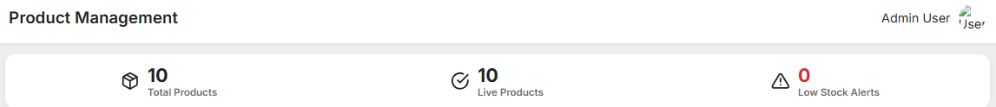

Product Inventory Table
This is the main list view for managing the products.
Search Bar: Allows an administrator to quickly search for a product by its ID or Name.
New Product Button: A primary action button to add a new item to the inventory list.
Publish- Allows the admin to show the products on the user side
Edit- Allows the Admin to freely edit the information of a certain product
Delete- Allows the admin to Delete a certain product
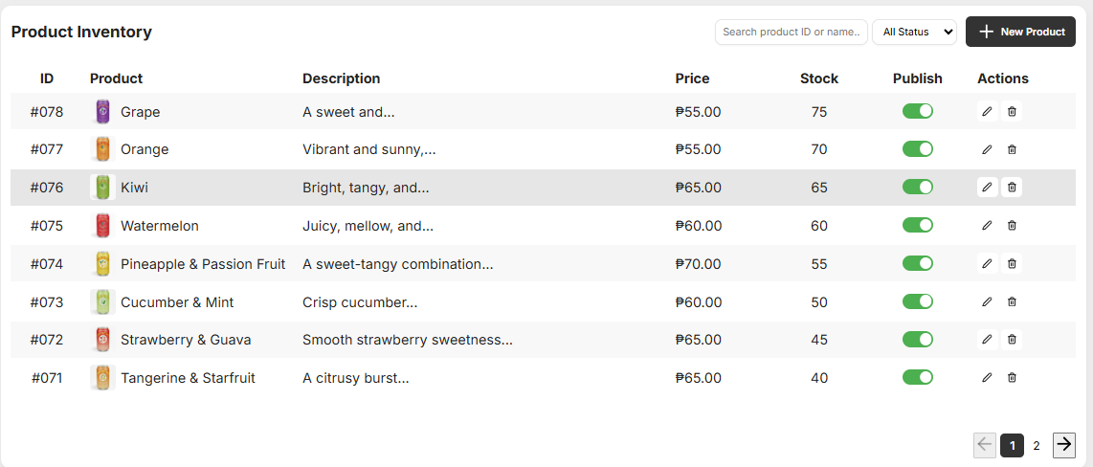
Add New Product
Form Sections
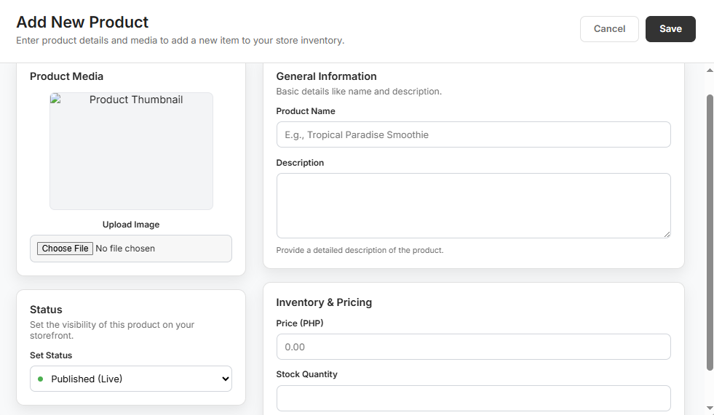
The form is logically divided into four main sections for data entry:

Product Media
This section handles the visual representation of the product.

Product Thumbnail: A placeholder box indicating where the main product image will be displayed.
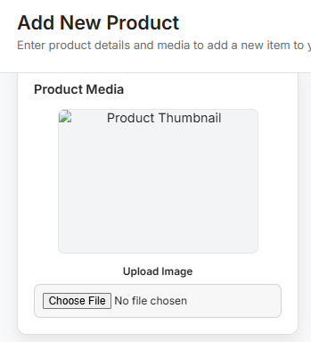
Upload Image / Choose File: A file picker control that allows the administrator to select an image file from their local computer to upload as the product's thumbnail.

General Information
This section covers the basic, descriptive details of the product.
Product Name: A text field for entering the name of the product.
Description: A large text area for providing a detailed, comprehensive description of the product.
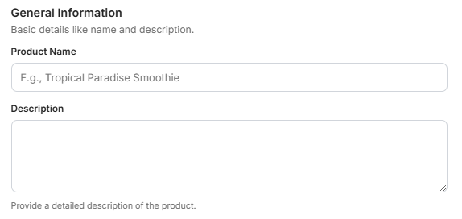

Status
This section controls the immediate visibility of the product on the storefront.
Set Status (Dropdown): A selection box to set the publication status.
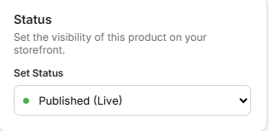
Published (Live), meaning the product will immediately be available for customers to see and purchase once the form is saved. Other options likely include "Draft" or "Hidden

Inventory & Pricing
This section covers the transactional and stock-related details.

Price (PHP): A numerical field for setting the selling price of the product, with the currency noted as Philippine Peso (PHP)
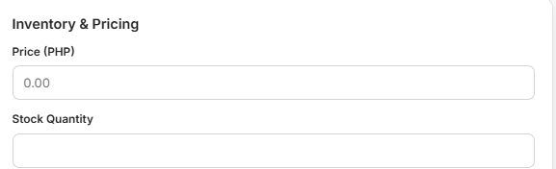
Stock Quantity: A numerical field for setting the initial amount of the product available in the store's inventory.

Action Buttons
Cancel: Closes the "Add New Product" form without saving any entered data.
Save: Submits the entered product details to the system, creating the new product entry in the inventory.


Order Subpage
Order Table-The main interactive table displaying core transaction data. It allows for quick scanning and management of orders.
Order Identification-Essential unique identifiers. The Order ID links to the confirmation page and tracking system, while the Customer Name allows for quick lookup and personalized service.
Financial & Time Data-Critical data points showing when the order was made and the final monetary value of the transaction.
Order Lifecycle Status-Uses clear, color-coded badges to indicate the order's current stage in the fulfillment pipeline: Pending (Awaiting payment/approval), Processing (Preparation/Packing), Out of Delivery (In transit with courier), and Delivered (Order complete).
Search Function-Allows admins to quickly locate a specific order by entering the Order ID, Customer Name, or potentially the Date.
Sort Function-Enables the admin to reorder the table data for prioritization, typically by Date (Newest/Oldest) or Total Amount (High/Low).
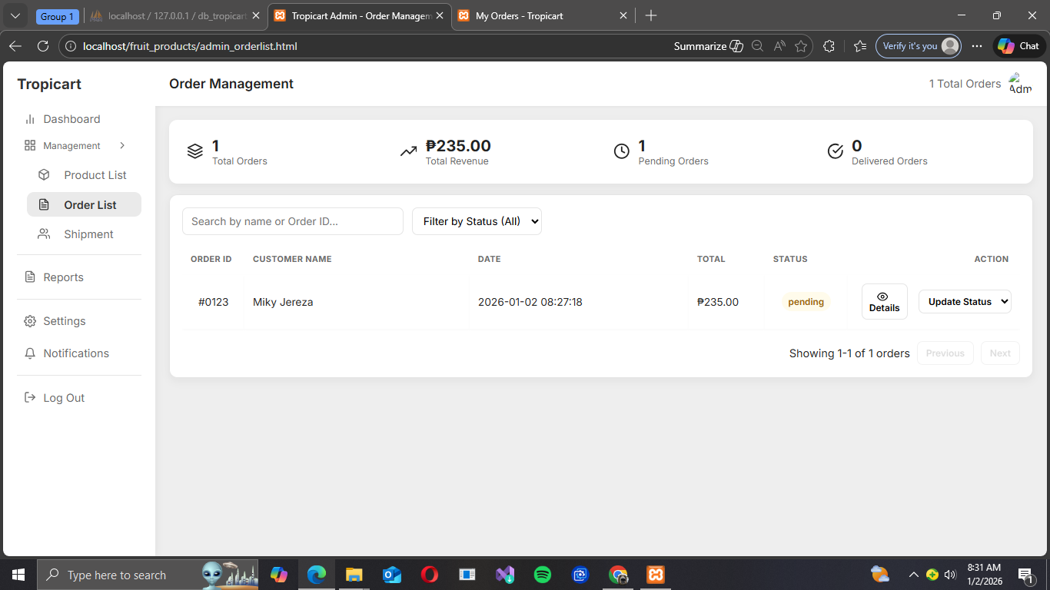

Updating the data (Processing to the Shipment page)
Status Update- Admin can manually change and order’s status. This drives customers' communication and internal workflow.
Status Progression: Pending and Processing (The color name changes upon changing yellow for pending and blue for processing)
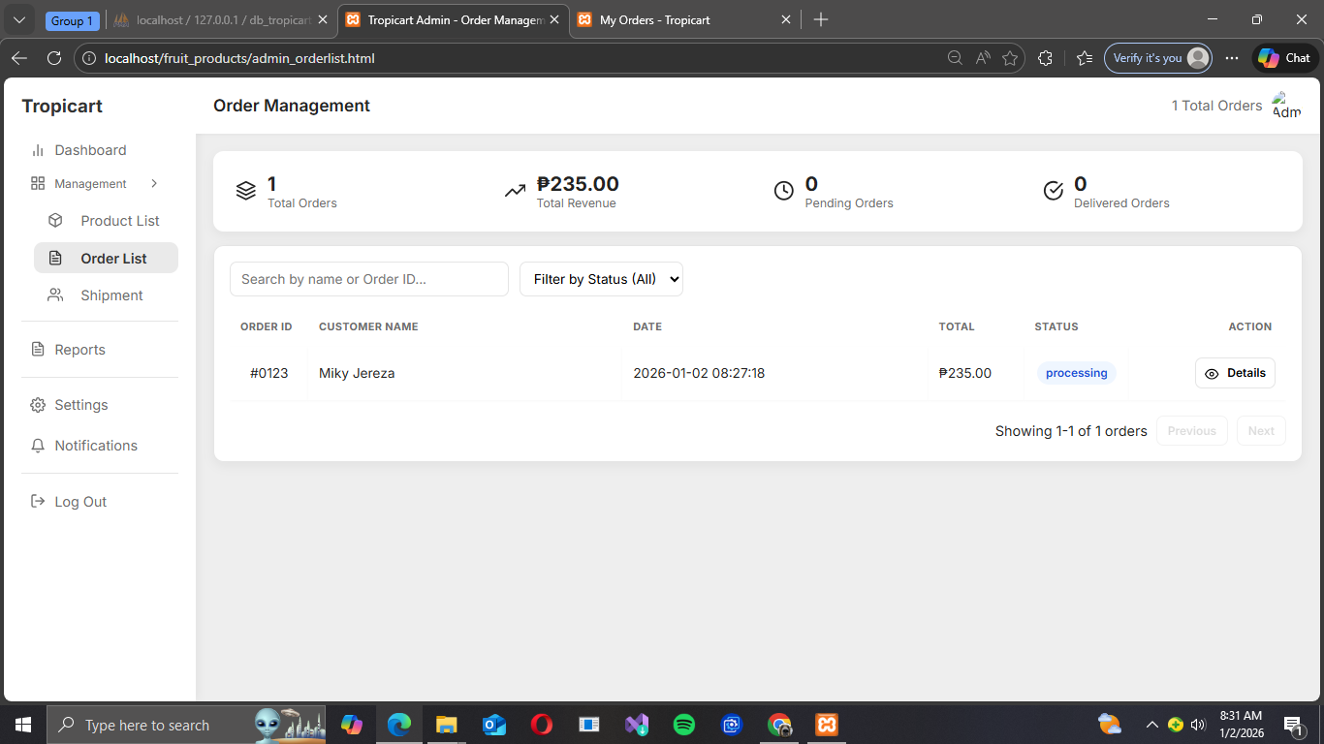

Shipment Page
Overview
Once the product is being processed, the order would go to the Shipment page, this is where the order can be tracked.

Inside of the Shipment Page
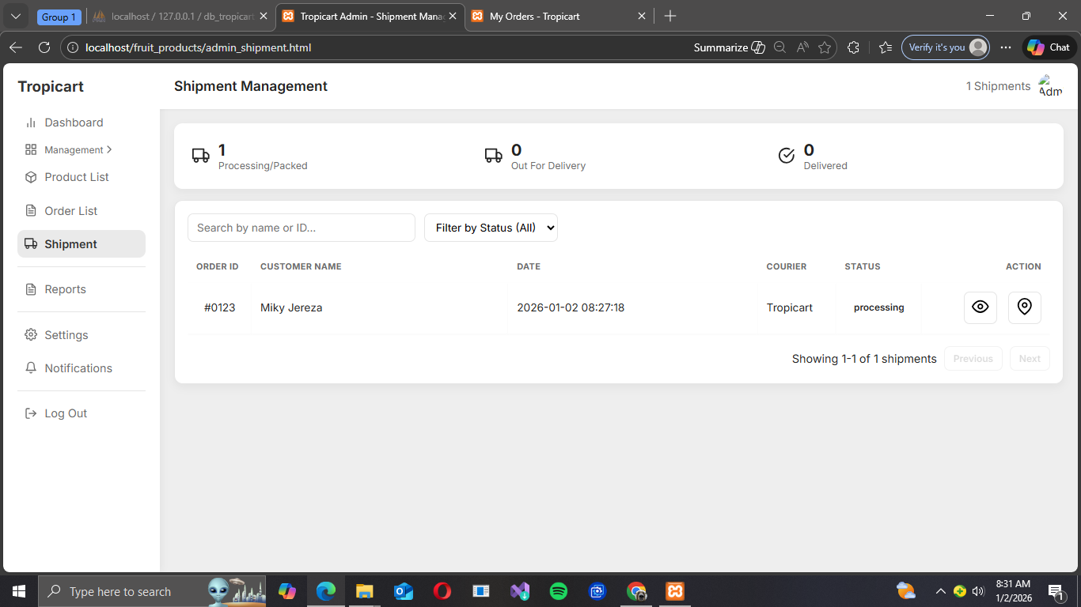

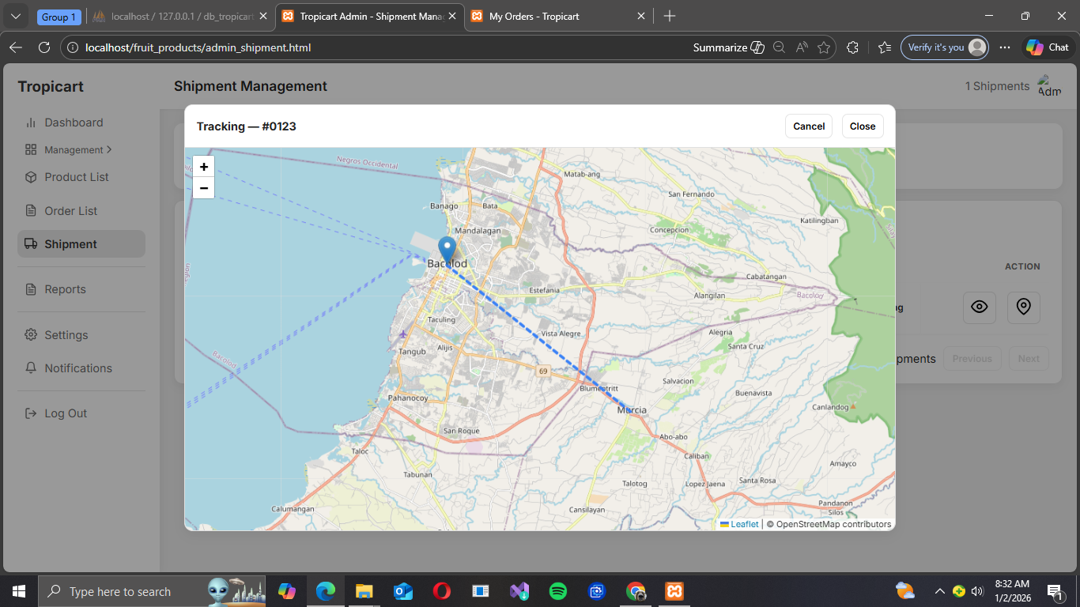
When they clicked the location icon

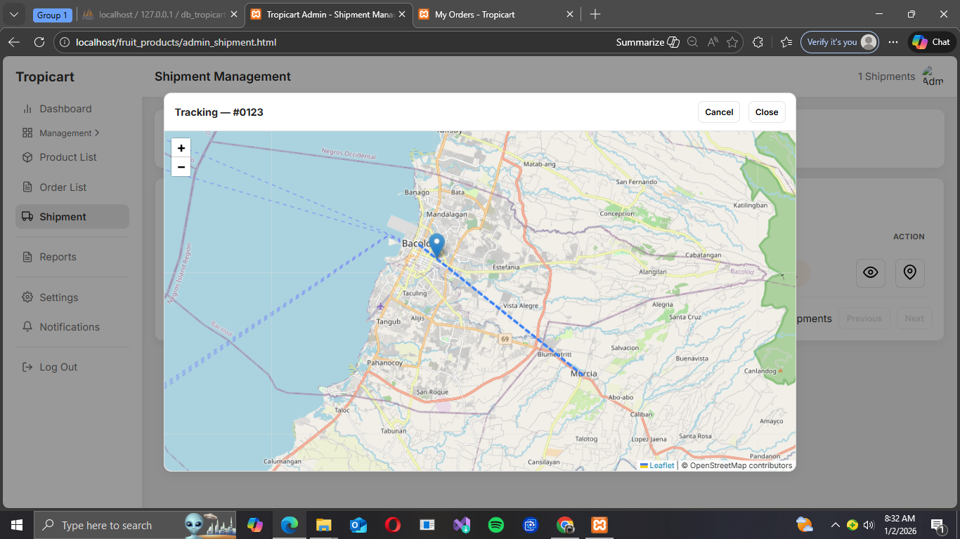
Showing proof that the it is moving

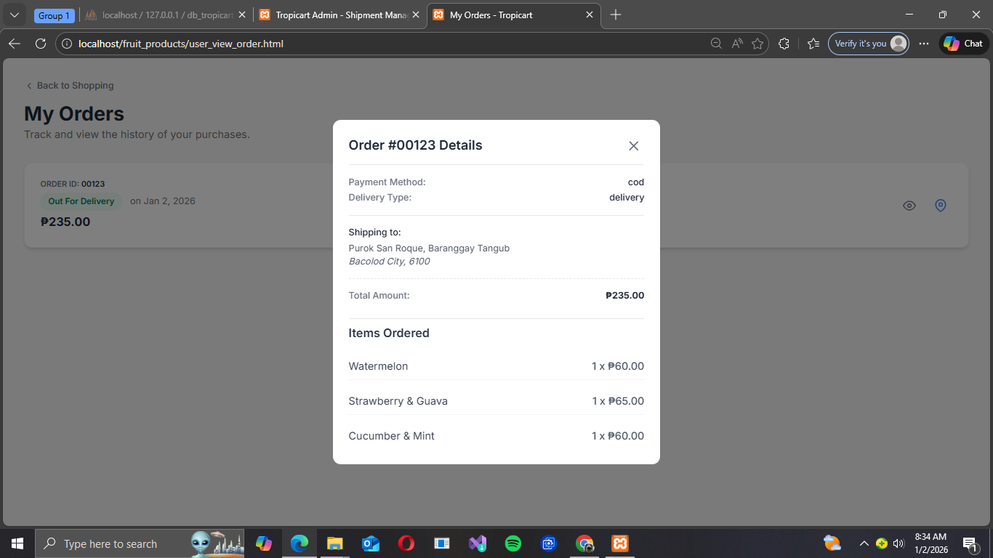
On the user side it would also update when the products are out for delivery

Proof that the product is out for delivery
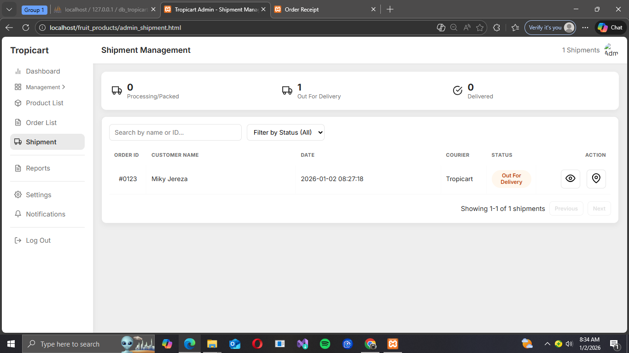

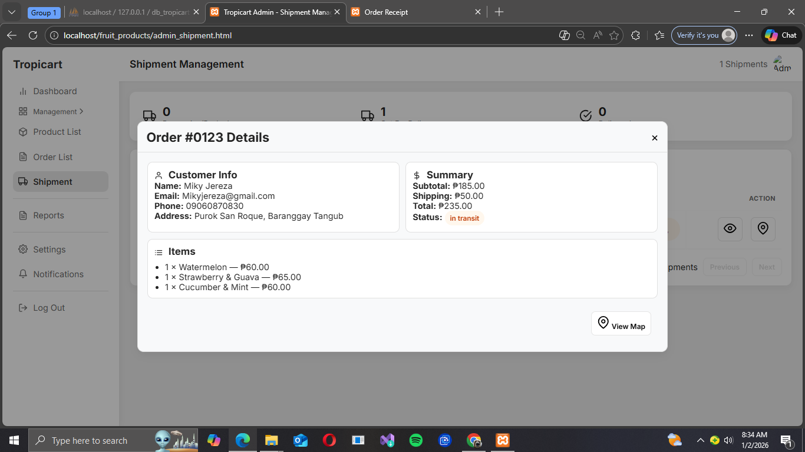
A modal will show up when the admin clicks the Eye Icon which summarize the transaction

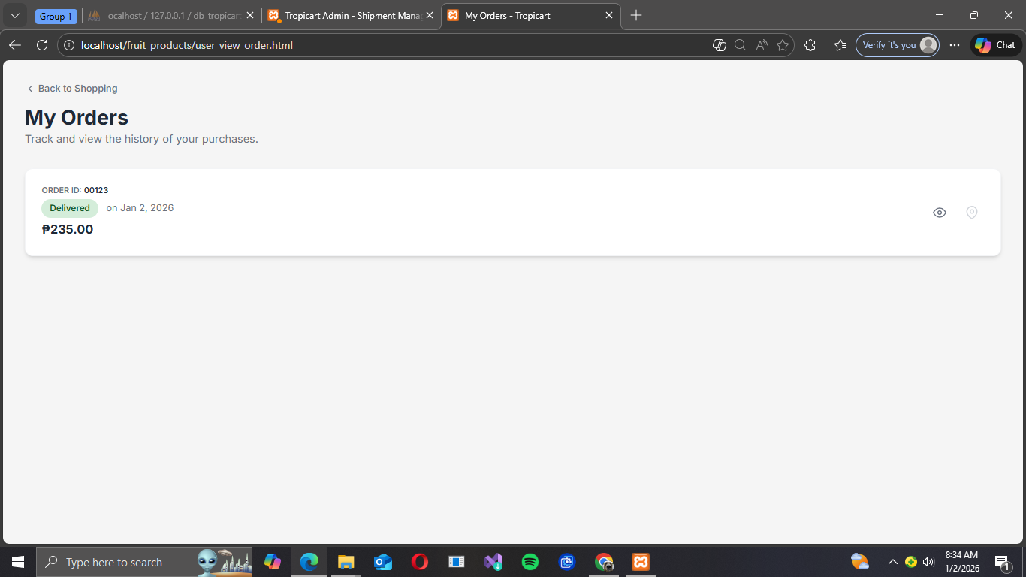
When the product reach the destination (User side)

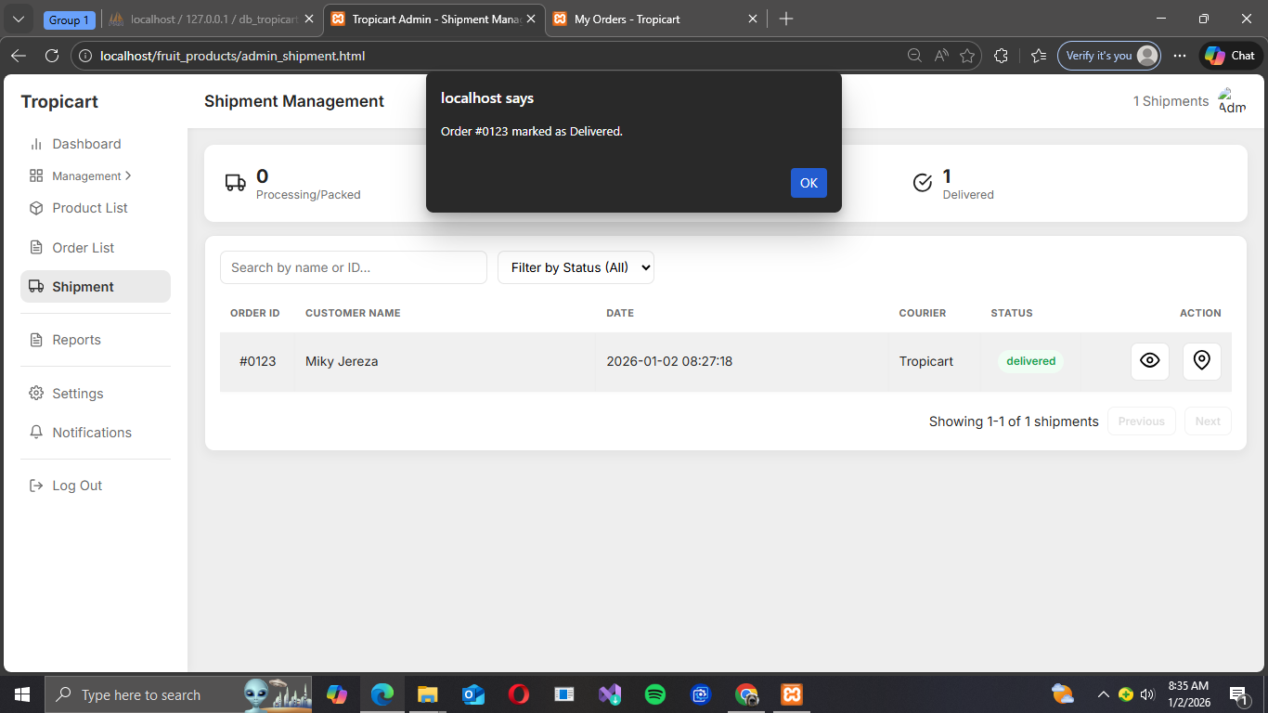
A notification would pop up also when the the product reach its destination on the admin side

Sales Reports & Analytics
The primary goal of this page is to give administrators an in-depth analysis of product performance and revenue trends over time.
Overview
Located at the top, these cards provide immediate financial health metrics based on the current time period selected.
Total Revenue-The total monetary value generated by all confirmed sales for the reporting period (e.g., Daily, Weekly, Monthly). This is the key measure of financial success.
Total Number of Orders-The total quantity of separate customer transactions completed within the reporting period. This measures customer acquisition and frequency
Average Order Value (AOV)-Calculated as Total Revenue / Total Number of Orders. This metric indicates how much, on average, a customer spends per transaction, which is critical for measuring marketing and upselling effectiveness.

Sales Trend Visualization
This section uses dynamic charts to illustrate how revenue changes over time, allowing the admin to spot trends and anomalies.
Trend Analysis Chart: Daily/Weekly/Monthly Revenue Line Graph
Time Control: Includes selectors (e.g., Daily, Weekly, Monthly) to allow the admin to dynamically change the report's granularity and see different trends
Best-Selling Products Chart: Product Sales Distribution (Pie Chart)
Product Performance: Clearly shows which products are the most sold,helping inventory managers prioritize stock and marketing teams focus promotions.
Time Period Selectors
Dynamic Granularity: Allows the admin to toggle the view of the data between:
Daily: For short-term operational insights and performance tracking.
Weekly: For consistent, mid-term performance checks.
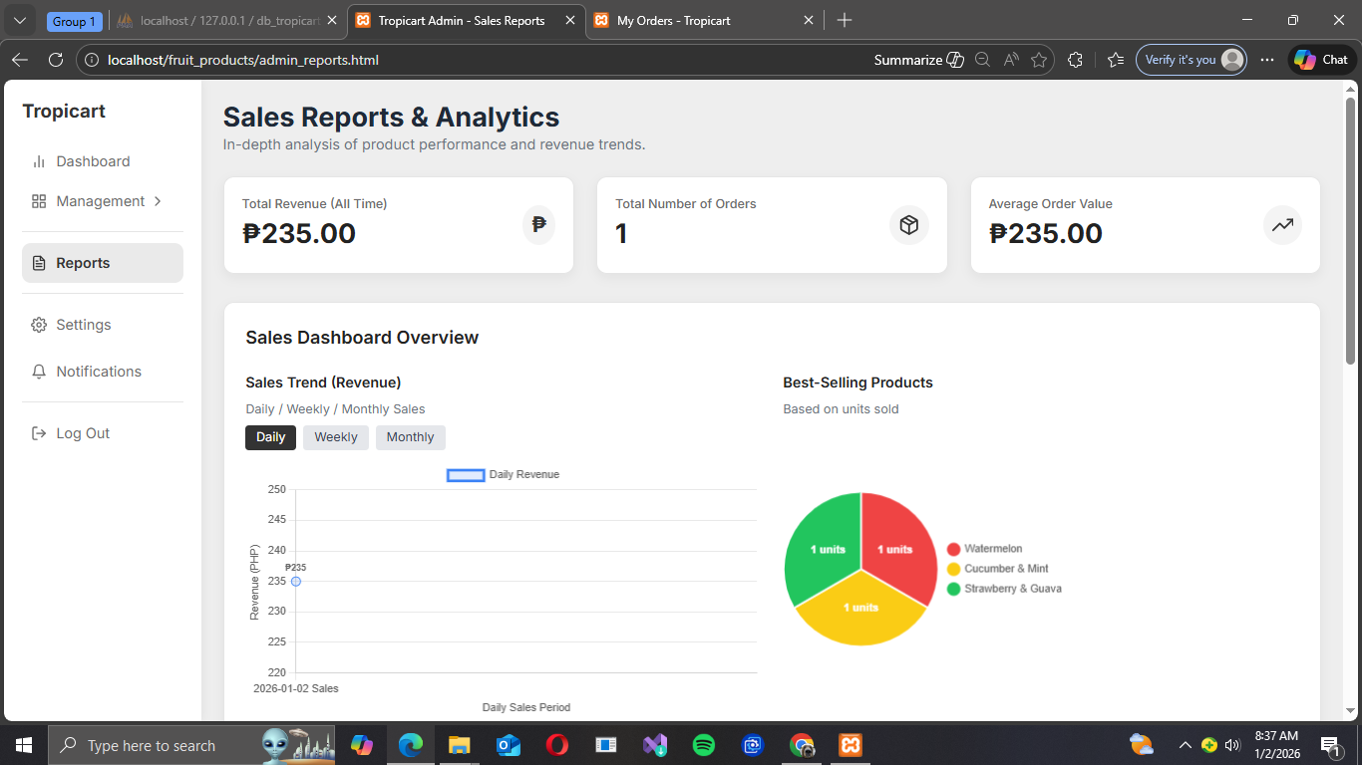
Monthly: For long-term growth analysis and financial planning.

Additional Sales Report
This section provides granular product performance analysis, crucial for understanding which items are driving the most profit.
Top Products by Revenue
Visualization: Horizontal Bar Chart for the purpose of clearly ranking products based on the highest revenue earned (PHP). This guides administrators on which products to keep consistently stocked and prioritize for promotions.which displays Product Name and Revenue

Revenue Contribution
This feature breaks down the total income into percentages, showing how reliant the business is on its top products
Visualization: Pie Chart to quickly visualize the share of total revenue each product contributes. This helps admins assess risk.The data being displayed are the Percentage Breakdown which Each slice represents the percentage of total revenue for a specific product and Legend for providing the color-coding key linking the product name to its corresponding slice and percentage
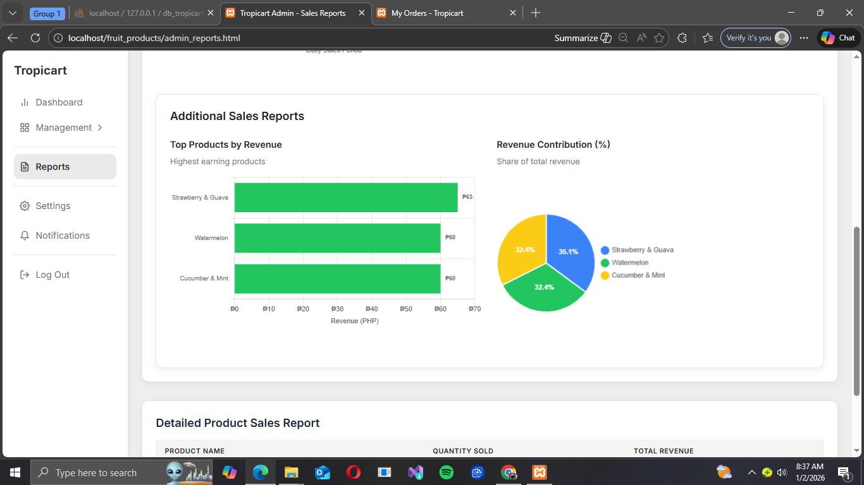

Detailed Product Sales Report
Overview
This table serves as the definitive record of individual product sales performance within the reporting period. Its purpose is to provide clear, numerical data for every transaction that occurred.

Table
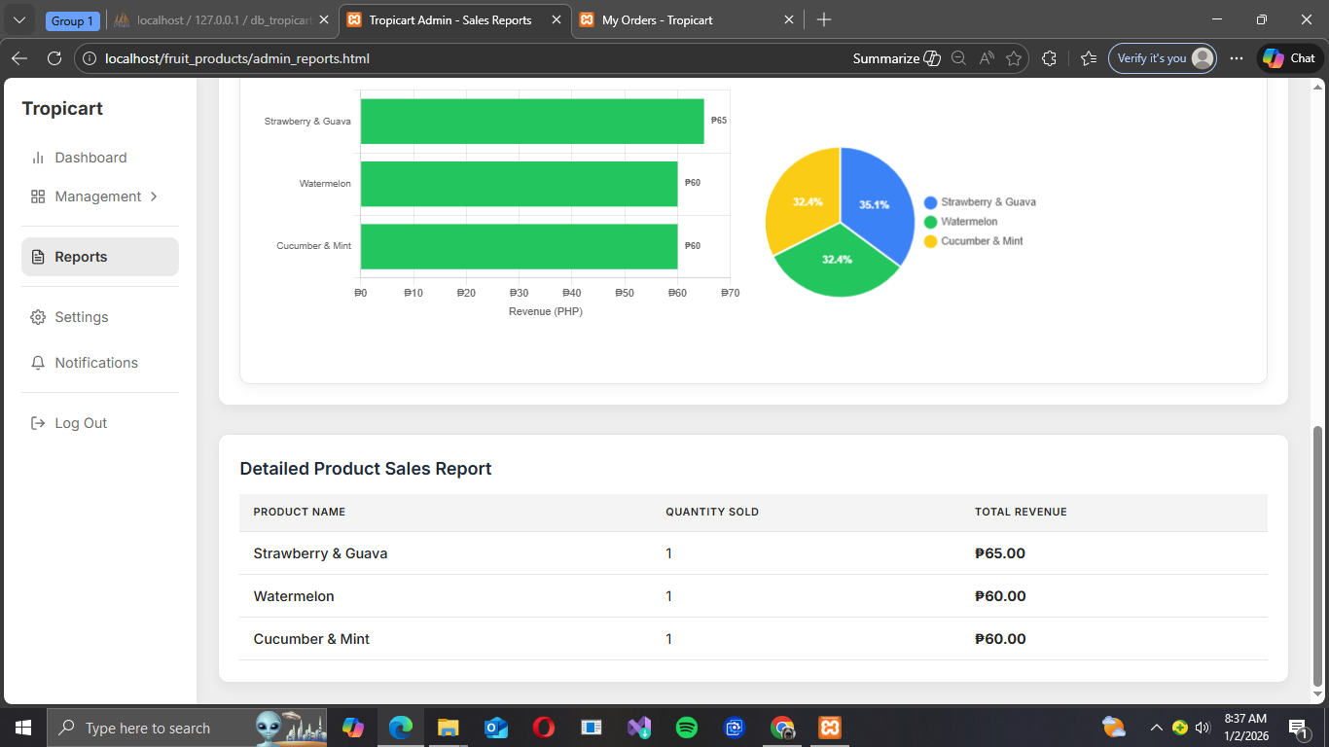
The table structure ensures that administrators can quickly reference the exact performance metrics for any listed product which shows the Product Name,Quantity Sold and Total Revenue this data dynamically update based on the controls in the Sales Reports & Analytics Overview section.The data displayed in this table will change depending on whether the admin selects Daily, Weekly, or Monthly data views.

What is the system aimed to solve or to automate?

The Tropicart e-commerce system is fundamentally designed to solve the significant problem of access and availability for consumers seeking authentic, specialty tropical drinks and flavors that are virtually impossible to source locally due to geographical barriers and complex import logistics. To bridge this gap, the system's primary automation goal is to streamline the entire global fulfillment chain for cross-border Direct-to-Consumer (DTC) shipping. This involves automating core business processes, including real-time order processing, inventory management across multiple small tropical suppliers, generation of complex international shipping documentation, secure payment handling, and managing the required customs and duties clearance, all while ensuring a seamless, fast, and reliable delivery experience for the global customer base

Why is it useful?
The Tropicart system is useful because it provides significant value across the entire supply chain, benefitting both consumers and producers. For consumers, it delivers unparalleled access and convenience, allowing them to bypass physical store limitations and effortlessly purchase specialty, hard-to-find tropical beverages from around the globe, satisfying their demand for exotic flavors and health-conscious alternatives. For producers—often small to medium-sized tropical businesses—it acts as a vital global distribution channel, granting them direct market access to an international customer base without needing to navigate the complex logistics, import regulations, and high costs typically associated with traditional wholesale exporting. Ultimately, the system is useful because it efficiently unlocks a specialized niche market, offering unique flavors to global consumers while simultaneously promoting sustainable growth and international reach for tropical island economies.

Overview of Technologies Used
The Tropicart e-commerce system uses a classic, cost-effective LAMP stack variant for its foundation, combining fundamental web technologies to create a functional online store. The front-end experience is built using HTML for content structure, CSS for visual styling, and JavaScript (JS) for interactive elements like product filtering and animations, while JSON is used as a lightweight data interchange format for fetching product details and managing cart information asynchronously. The backend and development environment are powered by XAMPP, which provides a local server environment (Apache, MySQL, PHP) for managing dynamic content, handling user sessions, and connecting to a database. Finally, the Google Maps API is a crucial integration, enabling essential e-commerce functions such as precise address validation during checkout, providing visual confirmation of the delivery location, and potentially optimizing last-mile delivery logistics, all vital for an international drinks platform.

Database Design
ERD Designer
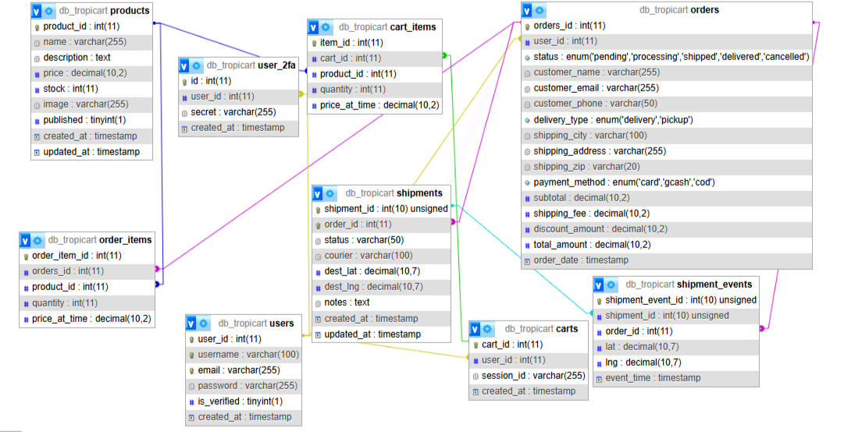

Database Tables Description
- db_Tropicart.products
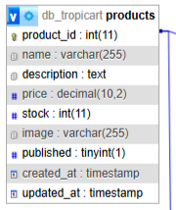
This is the main catalog of items for sale. The purpose is to store all the product information, including the price and current inventory level. The key fields include the product_ID, which is the primary key and also identifier for each product. We also have Name, Description, Details, Price, and Availability Quantity.

Table#1
Products
Column Name | Data Type | Key/Attribute | Description
product_id | int(11) | Primary Key (PK) | Unique identifier for each product.
name | varchar(255) |  | The name of the product.
description | text |  | A detailed description of the product.
price | decimal(10,2) |  | The selling price of the product, with up to 10 total digits and 2 decimal places.
stock | int(11) |  | The current quantity of the product available in inventory.
image | varchar(255) |  | The file path or URL for the product's main image.
published | tinyint(1) |  | A flag (typically 0 or 1) indicating whether the product is visible and available for sale.
created_at | timestamp |  | The date and time the product record was first created.
updated_at | timestamp |  | The date and time the product record was last modified.

- db_tropicart.orders
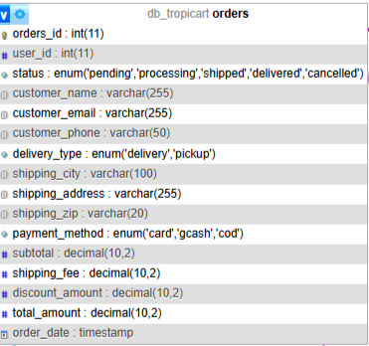
This table represents a customer's confirmed purchase. The purpose is to store the overall information of a completed order, including customer details, shipping information, and the final total amount. The key fields involved are the Order_ID. User_ID which is the foreign key, Status this explains the current state of the order (Ex: Pending, Shipped, Delivered). Total_amount, shipping_fee and the Order_Date

Table#2
Orders
Column Name | Data Type | Key/Attribute | Description
order_id | int(11) | Primary Key (PK) | Unique identifier for each order.
user_id | int(11) | Foreign Key (FK) | ID of the registered user who placed the order.
status | enum | Values: ('pending', 'processing', 'shipped', 'delivered', 'cancelled') | The current fulfillment status of the order.
customer_name | varchar(255) |  | The name of the customer placing the order.
customer_email | varchar(255) |  | The email address of the customer.
customer_phone | varchar(50) |  | The phone number of the customer.
delivery_type | enum | Values: ('delivery', 'pickup') | Specifies how the order will be received by the customer.
shipping_city | varchar(100) |  | The city for the shipping address.
shipping_address | varchar(255) |  | The full street address for shipping.
shipping_zip | varchar(20) |  | The postal or ZIP code for shipping.
payment_method | enum | Values: ('card', 'gcash', 'cod') | The method used for payment (Card, GCash, or Cash On Delivery).
subtotal | decimal(10,2) |  | The total cost of the items before fees and discounts.
shipping_fee | decimal(10,2) |  | The cost of shipping for the order.
discount_amount | decimal(10,2) |  | The total monetary value of any discounts applied.
total_amount | decimal(10,2) |  | The final amount the customer paid
order_date | timestamp |  | The date and time the order was placed.

- db_tropicart.order_items
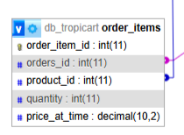
This table is connected to the product to the specific order. The purpose of this is that it tells the details which products were included in a particular order, the quantity purchased and the price at the time of the purchase. The Key fields include Order_item_ID, Order_ID and Product_ID are the foreign key for this table. Quantity.price_at_the_time which tells the details about the specific item in the order

Table#3
Order Items
Column Name | Data Type | Key/Attribute | Description
order_item_id | int(11) | Primary Key (PK) | Unique identifier for this specific line item within an order.
orders_id | int(11) | Foreign Key (FK) | ID linking to the main orders table, indicating which order this item belongs to.
product_id | int(11) | Foreign Key (FK) | ID linking to the products table, indicating the product that was ordered.
quantity | int(11) |  | The number of units of this specific product purchased in the order.
price_at_time | decimal(10,2) |  | The unit price of the product at the moment the order was placed. This ensures pricing accuracy even if the main product price changes later.

- db_tropicart.users
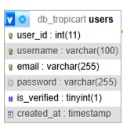
This table stores the essential account information for customers. The purpose of this table is to hold users credentials and contact information for anyone who registers on the site. The key fields are the Users_ID, Email, password and is_verified.

Table#4
Users
Column Name | Data Type | Key/Attribute | Description
user_id | int(11) | Primary Key (PK) | Unique identifier for each registered user.
username | varchar(100) |  | The user's chosen unique screen name or alias.
email | varchar(255) | Unique Index | The user's primary email address, often used for login.
password | varchar(255) |  | The hashed and secured password for the user's account.
is_verified | tinyint(1) |  | A flag (0 or 1) indicating if the user's email or account has been verified.
created_at | timestamp |  | The date and time the user account was created.

- db_tropicart.user_2fa
This table is for two-factor authentication, The purpose of this is to store the secret key and User_ID needed to enable and verify two-factor authentication for enchanted account security.
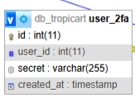

Table#5
F2a
Column Name | Type | Key/Attribute | Description
id | int(11) | Primary Key (PK) | Unique identifier for this 2FA record.
user_id | int(11) | Foreign Key (FK) | ID linking to the users table, identifying the user this 2FA record belongs to.
secret | varchar(255) |  | The secret key or token used to generate one-time passwords (e.g., TOTP secret). This is a critical security value.
created_at | timestamp |  | The date and time the 2FA secret was generated or enabled for the user.

- db_tropicart.carts
This table shows a customer’s shopping cart. The purpose is to store a reference for each active shopping cart, linking it to a user. The key fields are the Cart_ID and user_Id,session_id
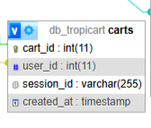

Table#6
Cart
Column Name | Data Type | Key/Attribute | Description
cart_id | int(11) | Primary Key (PK) | Unique identifier for each individual shopping cart.
user_id | int(11) | Foreign Key (FK) | ID linking to the users table for logged-in customers. (This column is often Nullable if guests are allowed.)
session_id | varchar(255) |  | A unique identifier for guest users who are not logged in, allowing their cart to persist during a session.
created_at | timestamp |  | The date and time the cart was initially created.

- db_tropicart.cart_items
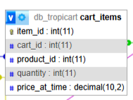
This table is the linking table that connects products to a specific shopping cart. The purpose is to list the products currently in a specific cart, their quantity and their price. The key fields includes Items_ID, Cart_ID and Product_ID are the foreign keys and Quantity.price_at_time

Table#7
Cart Items
Column Name | Data Type | Key/Attribute | Description
item_id | int(11) | Primary Key (PK) | Unique identifier for this line item within a cart.
cart_id | int(11) | Foreign Key (FK) | ID linking to the carts table, indicating which cart this item belongs to.
product_id | int(11) | Foreign Key (FK) | ID linking to the products table, indicating the product being held in the cart.
quantity | int(11) |  | The number of units of this specific product the user wants to purchase.
price_at_time | decimal(10,2) |  | The unit price of the product when it was added to the cart, recorded for accurate checkout.

- db_tropicart.shipments
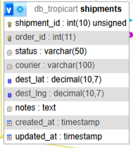
This table tracks the delivery details for an order. The purpose of this table is to store the logistical information for shipping and order, including status and tracking details. The key fields are the Shipment_ID, Order_ID is the foreign for this table, status,courier which states the delivery and service provider and des_lat, dest_lng which is the geographic coordinates for the delivery location

Table#8
Shipments
Column Name | Data Type | Key/Attribute | Description
shipment_id | int(10) | Primary Key (PK) | Unique identifier for a specific shipment record. The unsigned attribute means it can only store positive numbers.
order_id | int(11) | Foreign Key (FK) | ID linking to the orders table, indicating which order this shipment is for.
status | varchar(50) |  | The current tracking status of the shipment
courier | varchar(100) |  | The name of the shipping company or delivery service handling the shipment.
dest_lat | decimal(10,7) |  | The latitude coordinate of the shipment's destination address.
dest_lng | decimal(10,7) |  | The longitude coordinate of the shipment's destination address.
notes | text |  | Any internal or external notes related to the shipment or delivery process.
created_at | timestamp |  | The date and time the shipment record was first created.
updated_at | timestamp |  | The date and time the shipment record was last modified.

- db_tropicart.shipment_events
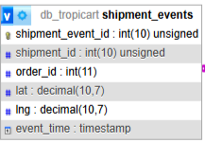
This table records every update during the shipping process. The purpose of this table is to store an historical log of location and time-based events for a specific shipment. Key fields involve Shipment_event_ID, Shipment_ID which is the foreign key for this table, lat and lng for the geographic coordinates of the event location and last is we have evcnt_time which explains the timeship of when the event is occurred

Table#9
Shipment Events
Column Name | Data Type | Key/Attribute | Description
shipment_event_id | int(10) | Primary Key (PK) | Unique identifier for a single tracking event.
shipment_id | int(10) | Foreign Key (FK) | ID linking to the shipments table, identifying the shipment that this event belongs to.
order_id | int(11) | Foreign Key (FK) | ID linking to the orders table (redundant but included for quicker lookups).
lat | decimal(10,7) |  | The latitude coordinate of the shipment's location at the time of the event.
lng | decimal(10,7) |  | The longitude coordinate of the shipment's location at the time of the event.
event_time | timestamp |  | The exact date and time the tracking event occurred.

Implementation Details
- How are the files being Structured
The files for the Tropicart application are organized using a modular architecture where resources are separated into three distinct, specialized containers. This approach ensures that files are easily found and managed, and it isolates critical components to prevent unintended dependencies or conflicts. which include the 3 major Modules, and these are the Code Module, Upload Module and Vendor Module

- Explanation of Important Modules
*Code Module- The Code Module, more accurately termed the Code Repository (or Version Control System), is the central, secure location where every single line of the Tropicart application's source code is stored and managed. It functions as the definitive "single source of truth" for the application's programming logic (HTML, CSS, JavaScript, and backend server code), tracking every change made by developers over time. This system is crucial because it allows development teams to collaborate efficiently, prevents code conflicts, enables developers to revert to any previous working state of the application, and is the essential foundation for deploying updates to both the Admin Panel and the User Side.

*Upload Module- The Upload Module, more accurately referred to as Static Asset Storage or a Cloud Storage Bucket, is the dedicated, separate system used to store and serve all non-code media files (assets) required by the Tropicart application. Its core function is to host high-volume files like product images, logos, and promotional graphics, which are large and numerous. By keeping these static assets separate from the core application code, the system ensures high scalability, reliability, and fast delivery of visual content to the user's browser, which is critical for a smooth and quick e-commerce shopping experience.
*Vendor- This module contains all the third-party libraries and frameworks that the Tropicart application relies on but did not write itself. This includes front-end frameworks (like Bootstrap, jQuery), back-end libraries (for database interaction, security), and utility packages. Placing these external components in a dedicated directory keeps the custom application code clean and allows for easy updates of external software.

- Form Handling and Server Side Validation
*Form Handling-encompasses the complete journey of user-entered data, beginning when the browser collects input from various form fields upon submission. The data is then packaged and transmitted to the server via a Submission Method, using GET for simple queries (data visible in the URL) or the secure POST method for sensitive data like passwords and credit cards. Upon arrival, the server-side application (like PHP or Python) executes Server-Side Routing, directing the incoming request to the specific function designed to handle that data. Finally, the server performs Data Extraction, successfully isolating the individual submitted fields and values from the request body for processing.

*Server-Side Validation is the essential security checkpoint that verifies and cleans all user-submitted data after it leaves the browser but prior to its use (such as saving it to the database or processing a payment), and it is considered the definitive security measure because client-side validation is easily bypassed by malicious users. Its core functions include Data Integrity Checks, which ensure all required fields are present and that data types are correct (e.g., verifying an email address is not empty and has a valid format); Business Logic Checks, which verify data against specific business rules (e.g., confirming a product price is greater than zero); and Database Uniqueness Checks, which prevent duplicate entries like a registered admin username or customer email address. Most critically, it involves Sanitization & Escaping to remove or neutralize harmful characters (like stripping HTML/JavaScript tags to prevent Cross-Site Scripting or XSS attacks), and robust Error Handling, where the system rejects invalid data, sends a clear error message (e.g., "Password too short"), and redirects the user back to the form with their original valid inputs retained.

- Security Considerations
The comprehensive security strategy for Tropicart prioritizes protecting all sensitive layers, starting with Authentication Security, which mandates Secure Password Storage (Hashing) and the use of Two-Factor Authentication (2FA) for admins, along with Brute-Force Attack Prevention like rate limiting to protect accounts from unauthorized access. This is reinforced by Data Integrity and Input Security, which enforces strict Server-Side Validation and crucial measures like Sanitization and Escaping to prevent Cross-Site Scripting (XSS) and the use of Parameterized Queries to prevent SQL Injection when interacting with the database. Furthermore, Data Transmission Security requires HTTPS/SSL Enforcement across the entire site to encrypt all data in transit, and Payment Processing Security dictates that Tropicart achieve PCI DSS Compliance by delegating card handling to a secure third-party gateway, using Tokenization instead of storing sensitive payment details.

Data Integrity Requirements (Products)
The following are the entries (Products) used for testing:
- Blue Berry & Acai
Category: Drinks
Price: ₱ 70.00
Quantity/ Stocks: 30
Description:A rich fusion of blueberries and acai berries, delivering a deep, antioxidant-filled flavor with a smooth finish. Perfect for those who love bold and fruity blends.

Image:

- Lemon & Ginger
Category: Drinks
Price: ₱ 60.00
Quantity/ Stocks: 35
Description: A sharp splash of citrus lemon balanced with the warm spice of ginger. Energizing, zesty, and great for uplifting your day.
Image:


- Tangerine & Starfruit
Category: Drinks
Price: ₱ 65.00
Quantity/ Stocks: 40
Description: A citrusy burst from tangerines with the unique crispness of starfruit. Lightly sweet, refreshing, and distinctly tropical.

Image:

- Strawberry & Guava
Category: Drinks
Price: ₱ 65.00
Quantity/ Stocks: 45
Description:Smooth strawberry sweetness paired with fragrant tropical guava. A soft, fruity drink with a lush, refreshing aroma.
Image:


- Cucumber & Mint
Category: Drinks
Price: ₱ 60.00
Quantity/ Stocks: 50
Description: Crisp cucumber meets cool mint for a refreshing soda that feels clean, light, and rejuvenating. Ideal for hot days or a calming tropical sip.

Image

- Pineapple & Passion Fruit
Category: Drinks
Price: ₱ 70.00
Quantity/ Stocks: 55
Description: A sweet-tangy combination inspired by island sunsets. Juicy pineapple blended with exotic passion fruit creates the perfect tropical soda harmony
Image


- Watermelon
Category: Drinks
Price: ₱ 60.00
Quantity/ Stocks: 60
Description:Juicy, mellow, and summer-sweet,this watermelon soda tastes like a refreshing splash on a sunny beach day.

Image

- Kiwi
Category: Drinks
Price: ₱ 65.00
Quantity/ Stocks: 65
Description:Bright, tangy, and slightly sweet, this kiwi soda captures that signature tropical zing. A lively flavor perfect for adventure seekers.
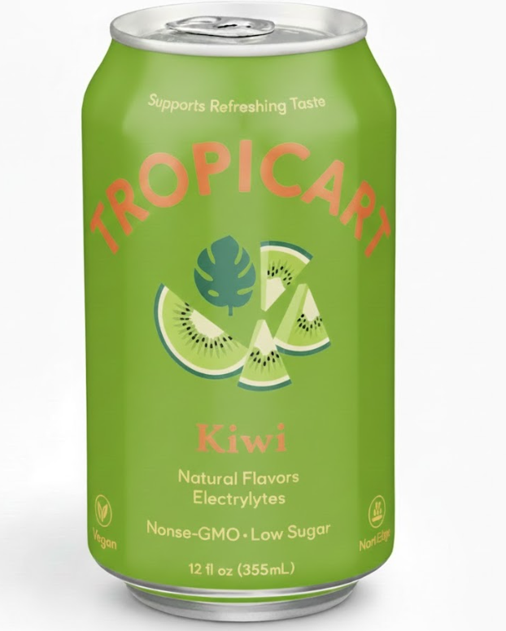
Image

- Orange
Category: Drinks
Price: ₱ 55.00
Quantity/ Stocks: 70
Description:Vibrant and sunny, this orange soda packs a bright citrus punch. Sweet, refreshing, and full of that classic tropical orange taste.
Image


- Grape
Category: Drinks
Price: ₱ 55.00
Quantity/ Stocks: 75
Description:A sweet and bubbly classic, elevated with a tropical twist. Each sip bursts with a juicy grape flavor that’s both nostalgic and refreshing.

Image

Data Integrity Requirements (Users))
The following are the entries (Users) used for testing:
ADMIN:
Full name: Elaine Mae L. Sandigan
Email: SandiganElaine7@gmail.com
Username: Elaine Sandigan
Role: Admin

USERS
1)Full name: Jeremiah T Roilo
Email: Jeremiahroilo620@gmail.com
Username: Jeremiah Roilo
Role: User

2)Full name: Christine Juban
Email: ChristineJuban721@gmail.com
Username: Christine Juban
Role: User

3)Full name: Trixie Nicole Jastillina
Email: JastillinaTrixie@gmail.com
Username: Trixie Jastillina
Role: User

4)Full name: Mikylla Niicole S Jereza
Email: Mikyjereza@gmail.com
Username: Miky Jereza
Role: User

